COUNTY OF ONONDAGA

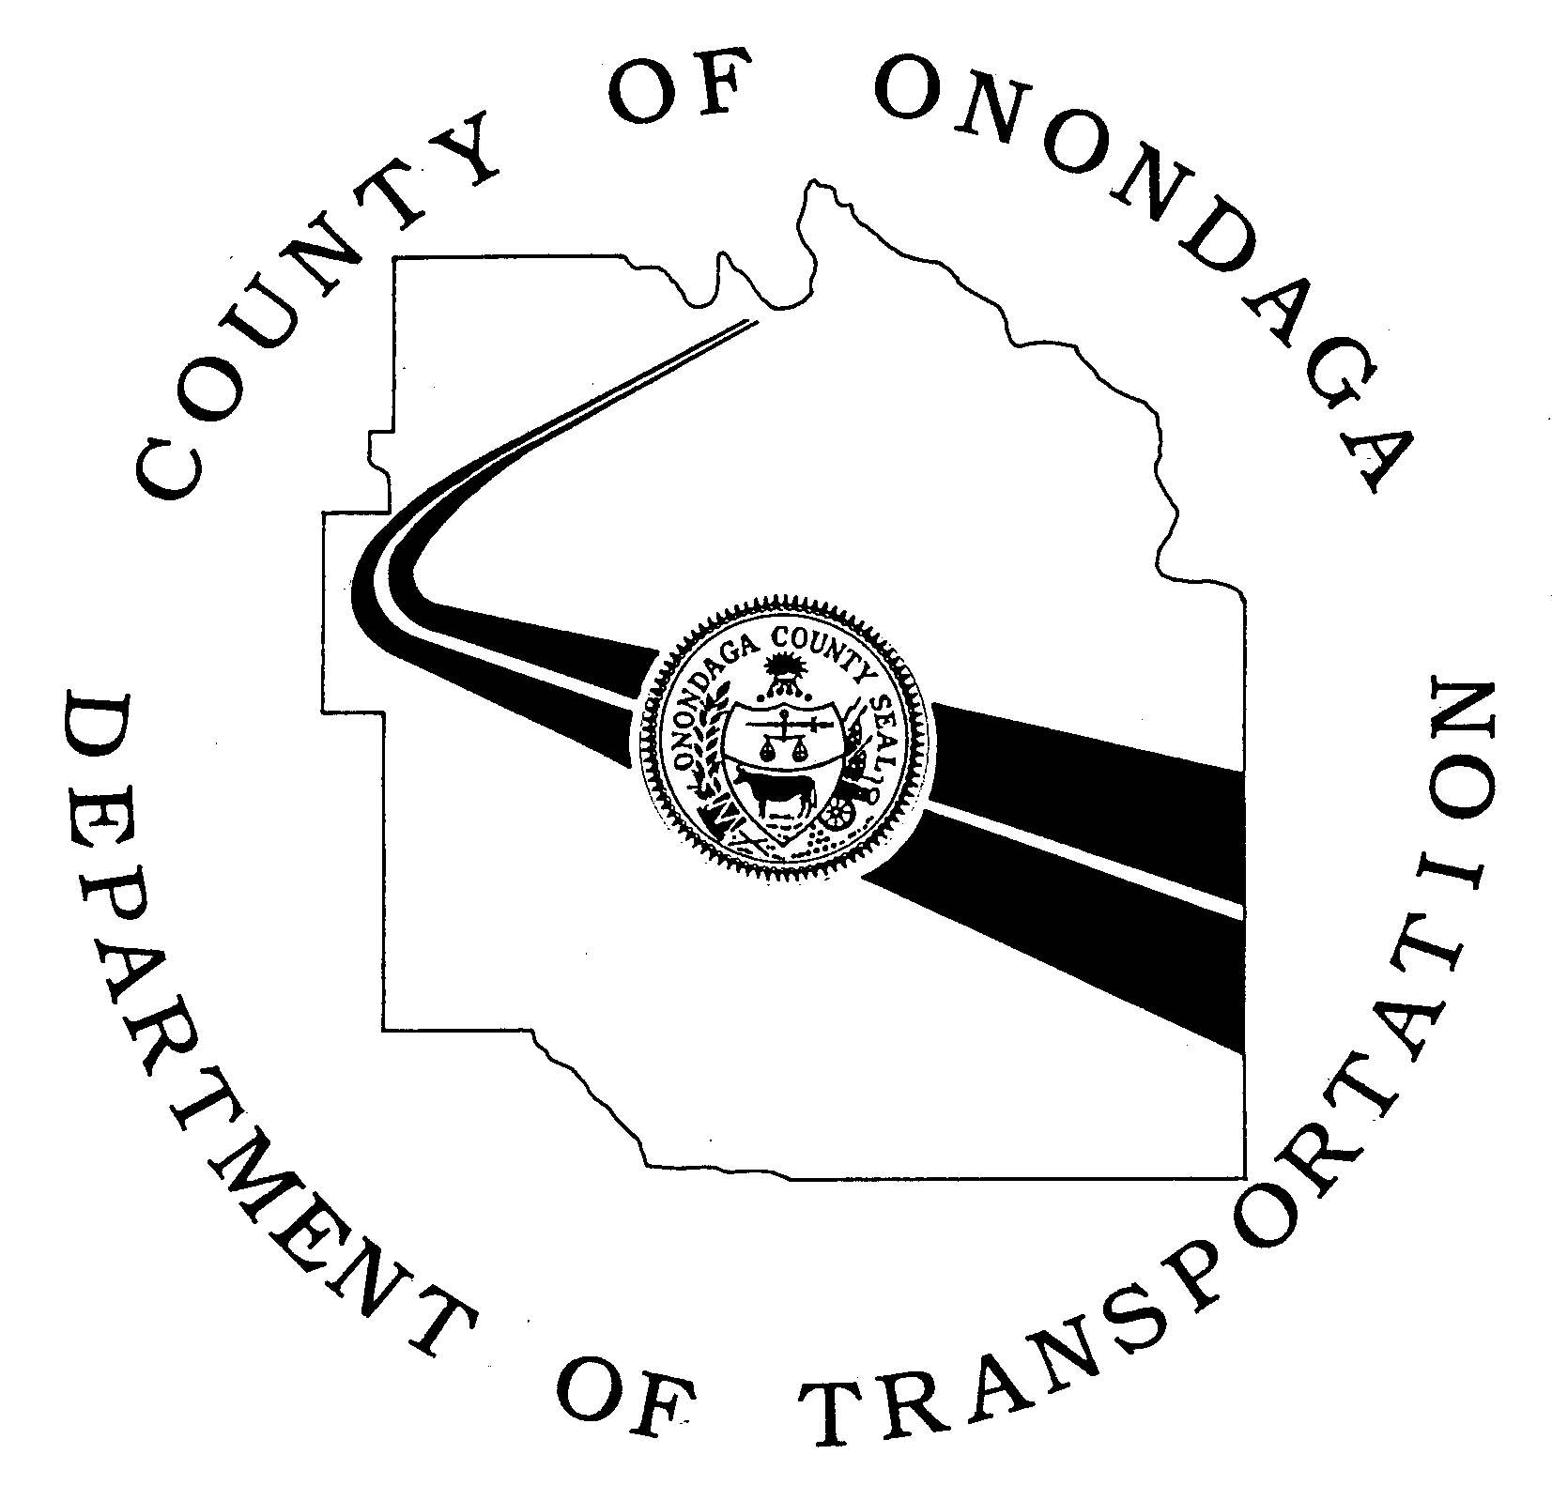

DEPARTMENT OF TRANSPORTATION
J. RYAN McMAHON II JOHN H. MULROY CIVIC CENTER MARTIN E. VOSS
County Executive 421 MONTGOMERY STREET, 11TH FLOOR Commissioner
SYRACUSE, NEW YORK 13202
Phone: 315.435.3205 Fax: 315.435.5744
ongov.net

APPLICATION FOR ADOPT-A-HIGHWAY PROGRAM

The Onondaga County Adopt-A-Highway Program Coordinator will work with the adopting group to determine the specific section of highway to be adopted. Such factors as width of right-of-way, geometrics, congestion, and reduced sight distance of roadways may be considered by the Program Coordinator in determining what roadways shall be eligible for adoption.

The Adopting Group agrees to perform the described work on the selected section of roadway at _____________________________________. Said work shall be performed in accordance with the Onondaga County Adopt-A-Highway Program guidelines.

The members of the Adopting Group agree to execute releases in order to indemnify and hold harmless Onondaga County, its officers and employees from all liability, judgment, costs, expenses and claims growing out of damages, or alleged damages of any nature whatsoever to any person or property arising out of the performance or non-performance of said work or participation in said program.

The members of the Adopting Group also agree to participate in the mandatory safety meetings, as required by the Program Guidelines.

Name of Adopting Group:________________________________________________________________
Mailing Address:_______________________________________________________________________
Group Leader Name & Address:___________________________________________________________
Telephone Number:_____________________________________________________________________
Approximate Number of people participating in each cleanup:___________________________________

Signature:___________________________________ Date:________________________________

Return this application to:
Patty Jeschke
Project Coordinator
Onondaga County Department of Transportation
421 Montgomery Street – 11th Floor
Syracuse, NY 13202

REVISED 02/13/2019

