COUNTY OF ONONDAGA

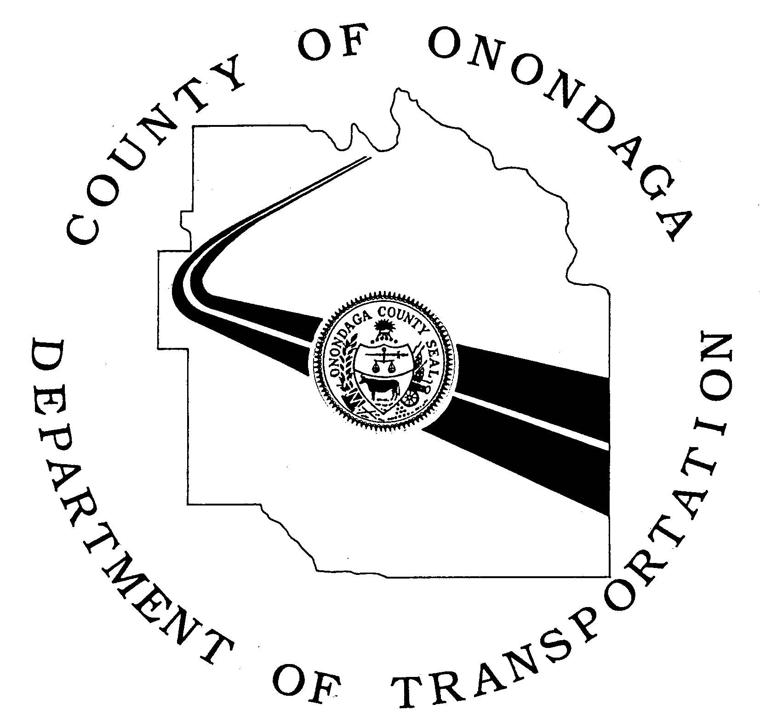

DEPARTMENT OF TRANSPORTATION
J. RYAN McMAHON II JOHN H. MULROY CIVIC CENTER MARTIN E. VOSS
County Executive 421 MONTGOMERY STREET, 11TH FLOOR Commissioner
SYRACUSE, NEW YORK 13202
Phone: 315.435.3205 Fax: 315.435.5744
ongov.net

ADOPT-A-HIGHWAY PROGRAM RELEASE FORM

I, ______________________________________________, am a voluntary member of the
_______________________________________ Group and, as such, have attended the roadside safety training program as a prerequisite to participation in the Onondaga County Adopt-A-Highway Program, and have reviewed the Onondaga County Adopt-A-Highway Program Guidelines.

I do herby release and discharge Onondaga County and its officers, agents and employees, from all claims, demands and causes of action of every kind whatsoever for any damages and, or, injuries which may result from my participation in the Onondaga County Adopt-A-Highway Program, and other voluntary activities on or near the roadway rights-of-way.

I further agree to hold harmless Onondaga County and its officers, agents and employees, from all claims, demands and causes of action of every kind whatsoever for any damages and, or, injuries which may result from my participation in the Onondaga County Adopt-A-Highway Program, and other voluntary activities on or near the roadway rights-of-way.

Participants Signature:_______________________________________ Date:____________________
Address:______________________________________________________________________________

If the participant is a minor, a parent or guardian must sign below.
Parent/Guardian Signature:____________________________________ Date:____________________
Address:______________________________________________________________________________

Return the signed Release Form to:

Patty Jeschke
Project Coordinator
Onondaga County Department of Transportation
421 Montgomery Street – 11th Floor
Syracuse, NY 13202

REVISED 02/13/2019

