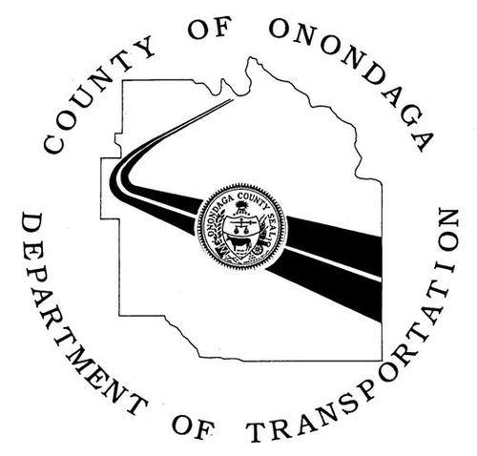
WORK ZONE ALERT

Date: January 29, 2020

Location: Intersection of Kinne Street and Kirkville Road

Type of Work: Power Outage

Schedule: Beginning Wednesday, January 29, 2020 – 11:00 a.m. to 3:00 p.m.

Impact: Traffic Signal will be black. Treat intersection as 4-way stop.

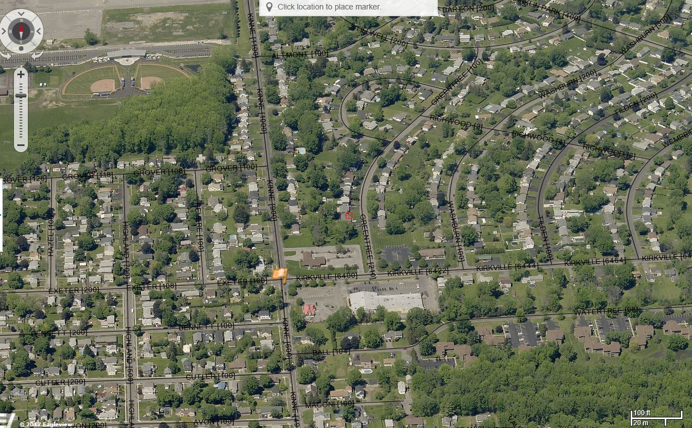

As with any roadway project, the Onondaga County Department of Transportation respectfully asks the traveling public to reduce your speed within the work zone, use caution, and be mindful of roadside workers and construction vehicles. For updates on this and other Onondaga County DOT projects, visit our website, or follow us on Facebook.

