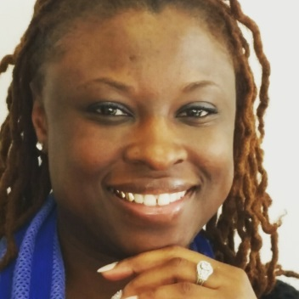 Dr. Najah Salaam Jennings Bey

For over 15 years Dr. Salaam has served children and families throughout the Syracuse community; the last two as a vice principal. Prior to serving as a public school administrator, she served as a Spanish teacher for high school students, the director of community services at a local not-for profit agency, and a program coordinator for the High School Graduation Initiative. In her latest publication, Urban Violence and Schools: Perspectives of High School Graduates Dr. Salaam Jennings-Bey examined the psychosocial impact of neighborhood violence on SCSD graduates. Dr. Salaam Jennings-Bey graduated with a Bachelors of Arts degree in English, Masters of Science in Teaching, and CAS in School Building Leadership from Lemoyne College. In 2015, Dr. Salaam Jennings-Bey earned a doctorate in Executive Leadership through St. John Fisher College in Rochester, NY. Dr. Salaam Jennings-Bey is best known for work with underserved youth and their families. In her spare time she enjoys spending time with her family and travelling abroad.

